**Risk assessment for non-crop legumes as hosts for Pea Enation Mosaic Virus and the vector *Acyrothosiphon pisum*: a community ecology approach**

Authors

Robert E. Clark1,2, Saumik Basu1, Sanford D. Eigenbrode3, Elisabeth C. Oeller3, David W. Crowder1

Affiliations

1 Department of Entomology, Washington State University, Pullman, Washington, USA

2 EcoData Technology LLC, Oxford, Connecticut, USA

3 Department of Entomology, Plant Pathology, and Nematology, University of Idaho, Moscow, Idaho, USA

1 Corresponding author. Email: [robert.e.clark@wsu.edu](mailto:robert.e.clark@wsu.edu)

**Abstract** (300 word limit for Journal of Applied Entomology)

Viral plant pathogens have devastating impacts on agricultural systems, and insects are frequent vectors for these diseases. However, most insect vectors of crop pathogens are herbivores with a diet-breath that encompasses both crop and non-crop hosts. Consequently, it remains difficult to map the potential risk of non-crop hosts for pathogens for herbivores with a wide diet-breadth. In this study we take a community-level approach to plant-vector-virus interactions to complete a risk assessment study for pulse crops. The pea aphid (*Acyrthosiphon pisum*), while specialized on legumes, has a relatively wide host range given the diversity of the host plant family it feeds on. We completed a large-scale field survey paired with molecular analysis of plant tissue to determine the presence of an economically important aphid-borne pathogen in pulse crops. This pathogen, pea enation mosaic virus (PEMV), undergoes periodic outbreaks that are difficult to predict with current models, and the reservoir for PEMV is unknown in the Palouse, a large agricultural production region. Our survey therefore included 65 sites along the Palouse where weedy plants were monitored within and outside dry pea fields in 2018. PEMV and high densities of its vector*, A. pisum*, were found in non-crop or cover-crop environments dominated by hairy vetch (*Vicia villosa*). *V. villosa* was the only legume other than cultivated pulses where PEMV was detected. Dense populations of *V. villosa* with pea aphids were only observed it in populations at low elevations not adjacent to dry pea fields. Our results suggest that *V. villosa* is an important alternative host for PEMV at the landscape scale. In dryland systems in the Western U.S. where it emerges earlier than dry pea and can reach high densities in disturbed, arid environments and consequently could be a source of crop pathogens.

**Introduction**

Insect herbivores can have devastating impacts on crop production by vectoring plant pathogens that cause damage far exceeding the economic impacts of feeding alone. Plant viruses contribute to an average 10% reduction in global agriculture productivity (Strange & Scott 2005). Additionally, most of these viruses require insects for transmission (Power 2000; Hogenhout et al. 2008). Despite the importance of vector-borne plant viruses in agriculture, our ability to predict their occurrence across time and space remains poor. Many vectors are generalists with a broad range of host plants, including both food crops, cover crops, agricultural weeds, and native plants (Mueller et al. 2012, Bommarco et al. 2007).

Like their vectors, many devastating crop viruses occupy alternative hosts before infecting crop plants (Norris & Kogan 2005). Non-crop hosts have been long established as important pathogen reservoirs for annual crops, including wheat, corn, and rice (Rashidi et al. 2020, Wu et al. 2020). Often, management strategies for crop pathogens rely on identification of non-crop hosts. Understanding pathogen movement among these many potential plant hosts is an important component of effective management of crop diseases.

When a non-crop host for pathogens or vectors is identified, integrated pest management (IPM) strategies suggest targeted removal to prevent crop infection (Catton et al. 2015). For example, management of wheat stem rust relies on control of the pathogen’s alternative host American barberry, a strategy that dates back almost a century and led to improved management of wheat stem rust (Peterson 2018). FNon-crop host removal can be difficult if these host plants are also agricultural weeds, particularly those that emerge early in the season before crops are established (Norris & Kogan 2005). Consequently, some agricultural weeds allow pest insect populations to increase before moving into crops. Colorado potato beetle is observed feeding on horse nettle before moving into potato (Mena-Covarrubias et al. 1996), and two spotted spider mites disperse from weeds to cotton (Wilson 1995, Norris & Kogan 2005).

When pests are vectors of pathogens, the subsequent move of pests into crops also spreads disease to crops (Srinivasan et al. 2008). Generalist vectors like aphids can use multiple host plants in both agricultural and non-agricultural habitats, allowing them to persist and sustain population growth both within and across growing seasons (Clark et al. 2019, Davis et al. 2015). Movement of aphids from infected non-crop hosts to susceptible crop hosts largely drives rates of infection (Power et al. 1991). With aphid species that are notably long-distance migrants, each spring there can be a re-establishment of population, and a subsequently high instance of virus-infected plants (Clement et al. 2010, Reynolds et al. 2006). For example, pea aphid alates can be blown by wind currents over long distances, frustrating local control efforts (Damgaard et al. 2020, Powell et al. 2006, Mueller et al. 2012). Consequently, aphid-borne viruses are difficult to track, and the frequency of outbreaks is highly variable, greatly hampering pest management efforts (Damgaard et al 2019). Given the dispersal distance and wide diet-breadth of generalist vectors like aphids, management requires identification of non-crop hosts are much larger special scales than within fields. Consequently, the goal of this study was to track and quantify the potential host plant community of vectors in a single region (eastern Washington state and Northern Idaho, USA), and identify which species may be important non-crop hosts on the landscape scale.

**Methods**

***Study System***

*Acyrthosiphon pisum* are frequent pests of pulse crops. These insects act as the primary vector for multiple devastating pathogens, including pea enation mosaic virus (PEMV) (Rashed et al. 2018). Infected plants are stunted with malformed pods and ultimately have reduced yield (Clement et al. 2010). Extreme outbreaks can devastate pulse production, leading to up to 40% yield loss (Elbakidze et al. 2011, Paudel et al. 2018). Pea aphids acquire PEMV from infected perennial legume hosts, but these are restricted to a handful of crops and agricultural weeds (Hull 1981). However, *A pisum* have a diet-breadth encompassing most of the Fabaceae, (Peccoud et al. 2009), suggesting the potential diversity of PEMV-compatible hosts could be quite large.

***Survey Design***

We employed large-scale field surveys in 2018 from May to July during an outbreak season of *A. pisum*. Aphid vectors for important crop diseases have been consistently monitored in eastern Washington and Idaho by University of Idaho using a long-term pan trapping network encompassing 17 sequential growing seasons. 2018 season had the second highest alate arrival counts on a per-trap basis over this entire 17 year period (Figure S1). This so-called “outbreak year”, thus facilitated a unique opportunity to discover which potential non-crop host *A. pisum* and a vectored pathogen use in a year when the insect is widespread. The goal of our sruveys were to identify the non-crop reservoir(s) for pea aphids and/or PEMV among a range of all common potential legume hosts. Plant and aphid communities were sampled in two climatic ecoregions, Palouse Prairie, a high-elevation grassland predominately converted to dryland wheat production (Looney et al. 2009), and shrub-steppe, a habitat found at lower elevations and warm slopes adjacent to the Palouse (predominately along the Snake River in Washington and Idaho) (Knick & Rotenberry 1997). Both habitat types harbor a diverse community of herbaceous legumes and are purported sources of pea aphid outbreaks (Clement book chapter on the aphids from alfalfa). All non-agricultural sites were in either edge habitats on the Palouse, native prairie, or shrub-steppe, while agricultural sites were spring-planted pea fields on the lower Palouse in Whitman Co. Washington and Latah Co. Idaho (Fig. 1).

Aphid, plant, and virus surveys all occurred using a line-transect and biological sampling approach. At each location we ran 10 m line transects and quantified the plant diversity (species identity) of all forbs. During each sampling event, the cover of all forbs was calculated as (% cover) based on measuring to cm the plant material covering the 10 m transect. At these sites we used sweep nets to collect all foliage-foraging arthropods, making sure to sweep each section of plant material twice. All insects collected were stored in 95% ethanol until they could each be identified to species. All forbs touching the line transect were identified to species and measured by percent cover. Samples of aboveground tissue (uppermost leaf) of legume species within the line transect were harvested, wrapped in aluminum foil, frozen in liquid N2, and snap chilled in dry ice before storing in -80°C. These tissue samples were used to determine PEMV presence or absence.

***Molecular methods***

To test all crop and non-crop legumes we used a two-stage approach to testing for evidence of PEMV. First, we completed rtPCR for each transect completed (n=65). To do so, we took several pieces of plant tissue from every single species collected at a given site, homogenized the sample, and then ran rtPCR on this mixed sample. If we observed a positive hit for PEMV, we then proceeded to test each legume species individually. Due to the cost and time constraints of rtPCR (1076 plant samples were taken in 2018), this approach allows us to rapidly determine which locations have PEMV, then identify afterwards which plant species harbored PEMV at the given location.

PEMV RNA was determined using rtPCR (Chisholm et al. 2018). This method provides an accurate score of the presence of at least one fully infected host plant within the population of those sampled. All plant tissue was ground in sterile conditions with a mortar and pestle and liquid nitrogen. We completed RNA extraction, cDNA synthesis, and PCR using PEMV primers for coat protein and testing for PEMV infection in plant samples in electrophoresis gels (kit was Dreamtaq DNR polymerase, Thermo Fischer Scientific. Not sure what primers were used -Vemulapati 2014 for primer citation? Methods following assay for recipient plants found in Clark et al. 2019). For the large population of hairy vetch that contained PEMV (Fig 1.) we revisited the site later in the field season and sampled vetch plants in disturbed habitat fragments. We verified that PEMV was present in adjacent habitats and likely a reservoir at the landscape scale (Fig S1).

***Statistical Analyses***

Analyses on % plant cover were completed using normally distributed generalized linear mixed models, while aphid counts, or cumulative abundance models used a negative-binomial distribution appropriate for zero-inflated count data. Statistical analyses for line transects used site (farm or open habitat sampled) as a random effect. Analyses of pooled long-term monitoring data from <https://www.legumevirusproject.org/> were completed using a negative binomial generalized linear model where monthly aphid counts per pan trap were analyzed over 17-year survey period (Fig S1).

**Results**

In our surveys, we completed 118 transects and surveyed five hairy vetch populations opportunistically. In all, we collected 15,289 aphids, and assayed 1076 candidate plant tissue samples for PEMV. In our transects we recorded 145 species of annual plants, of which 23 were in the family Fabaceae. We observed significant variation in the % coverage of non-crop legumes (Fig. 2) and the abundance of aphids among host plant species (Fig 3). Hairy vetch had the highest abundance of pea aphids and was the most abundant non-crop, weedy legume (Fig. 3). At the community level, GLMMs revealed a significant correlation between meters of vetch coverage in transects and likelihood of pea aphid presence (Fig 4. P < 0.0001, chisq = 15.02).

**Discussion**

Effective prediction and management of outbreaks of viral plant pathogens requires understanding their movement from crop to non-crop hosts at the landscape scale (Srinivasan et al. 2008). A first step in this process is risk assessment for potential alternative hosts. Hairy vetch appears to be an ideal alternative host for pea aphids and PEMV, which are major pests of pulses in the Palouse region of Pacific Northwestern US. We found this host has high densities in non-agricultural environments, persists in disturbed habitats, is correlated with aphid presence, and is validated as a competent host for PEMV.

Current understanding of pea aphid and PEMV outbreaks in the Palouse consider that pea aphids likely colonize Palouse agroecosystems following wind currents from the Columbia Basin and Willamette Valley, where milder winters allow populations to overwinter on alfalfa and clover (Clement et al. 2010, Hampton 1983). Genetic data has also demonstrated that the pea aphid biotype found on dry pea in the Palouse has shared genetic markers with biotypes collected in these areas (Eigenbrode et al. 2016). There are two possibilities compatible with this previous information. First, hairy vetch, which emerges earlier and is found in low elevations with earlier starts to the growing season, is an effective “stopover” population, where alates from the west land and begin to reproduce and increase in population, then dispersing to dry peas later in the summer. Second, hairy vetch does occur in relatively warm environments in microhabitats along the edge of the Palouse, and aphids may overwinter in these populations as vetch is a facultative biennial with an above-ground rosette available during ideal climatic conditions (Pokorny et al. 2020, Mischler et al. 2010, Clark personal observation). In either case, vetch acts as a short-term (months) or long-term (years) reservoir for aphids and PEMV, and therefore probably plays an important role in this pathosystems at the landscape scale.

Once non-crop hosts for economically important plant pathogens are discovered, certain management implications arise. In other systems, management of weeds showed reductions in pest populations in crops (Norris & Kogan 2005); however, removal of non-crop hosts may not be viable for several reasons. The non-crop host may be too expensive to control, or the movement of pests from one plant population to another may occur over long distances so local control is not an effective management strategy. Mainly that removal or reduction of the non-crop plant could be an effective tool for reducing the incidence of that pathogen (Peterson 2018, Strickland et al. 2020). However, given the current evidence and field observations, it is unclear if this strategy is tenable. Hairy vetch is intentionally planted as a cover crop for cattle forage, and this is likely why it is so abundant on dry slopes in eastern Washington and Idaho. Hairy vetch improves soil nitrogen, prevents erosion, and is not currently listed directly as a noxious agricultural weed in the region (Pokorny et al. 2020, Mischler et al. 2010). Given that the habitats are non-agricultural, removal of these weeds may not be feasible with traditional herbicide applications (Freemark and Boutin 1995). Our results suggest that in this region, cover cropping of hairy vetch may increase PEMV outbreak risk in dry peas if in the same fields, but further work on farm trials would be needed to verify this within-field spread occurs.

Finally, given the differences in phenology of cultivated pulses and vetches in the Palouse region (vetch emerges earlier, and hosts aphids earlier), this work implies an important tool may be available for extension support that aims to monitor for the prevalence of PEMV. Sampling hairy vetch populations for PEMV may be a way to indicate if there are risks of large-scale, catastrophic outbreaks of PEMV likely to occur each year. While we only have one season of data reported here, PEMV and aphid population go through large and difficult to predict population cycles. Consequently, it appears likely that if PEMV is found in April or early May in many hairy vetch populations along the lower Palouse, it would portend an area-wide impact of PEMV in the growing season for pulse farmers. Similar strategies could be employed in other non-crop and crop source-sink dynamics systems where the non-crop host is a perennial plant that emerges earlier in the growing season.

**Acknowledgments**

**Conflict of Interest Statement**

The authors declare no conflicts of interest.

**Author Contribution**

REC completed surveys and data analysis, REC and SB completed molecular assays, SDE provided long-term aphid trap data. DWC, SDE, and REC conceived project design. REC and ECO drafted manuscript and all authors contributed to writing and editing of the final version of this paper.

**Data Availability Statement**

Upon acceptance of this manuscript all data will be made available through Figshare data repository (https://figshare.com/).

**References**

Al-Karaki, G. N. (1999). Phenological development-yield relationships in dry pea in semiarid Mediterranean conditions. *Journal of Agronomy and Crop Science*, *182*(2), 73–78. <https://doi.org/10.1046/j.1439-037X.1999.00249.x>

Ali, M. P., Huang, D., Nachman, G., Ahmed, N., Begum, M. A., & Rabbi, M. F. (2014). Will climate change affect outbreak patterns of planthoppers in Bangladesh? *PLoS ONE*, *9*(3), 1–10. <https://doi.org/10.1371/journal.pone.0091678>

Bommarco, R., Wetterlind, S., & Sigvald, R. (2007). Cereal aphid populations in non-crop habitats show strong density dependence. *Journal of Applied Ecology*, *44*(5), 1013–1022. <https://doi.org/10.1046/j.0021-8901.2007.01332.x>

Catton, H. A., Lalonde, R. G., & De Clerck-Floate, R. A. (2015). Nontarget herbivory by a weed biocontrol insect is limited to spillover, reducing the chance of population-level impacts. *Ecological Applications*, *25*(2), 517–530. <https://doi.org/10.1890/14-0250.1>

Chisholm, P. J., Sertsuvalkul, N., Casteel, C. L., & Crowder, D. W. (2018). Reciprocal plant-mediated interactions between a virus and a non-vector herbivore. *Ecology*, *99*(10), 2139–2144. <https://doi.org/10.1002/ecy.2449>

Clark, R. E., Basu, S., Lee, B. W., & Crowder, D. W. (2019). Tri-trophic interactions mediate the spread of a vector-borne plant pathogen. *Ecology*, *100*(11), 1–8. <https://doi.org/10.1002/ecy.2879>

Clement, S. L., Husebye, D. S., & Eigenbrode, S. D. (2010). Aphid Biodiversity under Environmental Change. *Aphid Biodiversity under Environmental Change*, *January 2014*. <https://doi.org/10.1007/978-90-481-8601-3>

Damgaard, C., Bruus, M., & Axelsen, J. A. (2020). The effect of spatial variation for predicting aphid outbreaks. *Journal of Applied Entomology*, *144*(4), 263–269. <https://doi.org/10.1111/jen.12724>

Davis, T. S., Wu, Y., & Eigenbrode, S. D. (2015). Chickpea variety and phenology affect acquisition of Pea enation mosaic virus, subsequent plant injury and aphid vector performance. *Annals of Applied Biology*, *167*(3), 420–425. <https://doi.org/10.1111/aab.12239>

Deibert, E. J., & Utter, R. A. (2004). Field pea growth and nutrient uptake: Response to tillage systems and nitrogen fertilizer applications. *Communications in Soil Science and Plant Analysis*, *35*(7–8), 1141–1165. <https://doi.org/10.1081/CSS-120030595>

Eigenbrode, S. D., Davis, T. S., Adams, J. R., Husebye, D. S., Waits, L. P., & Hawthorne, D. (2016). Host-adapted aphid populations differ in their migratory patterns and capacity to colonize crops. *Journal of Applied Ecology*, *53*(5), 1382–1390. <https://doi.org/10.1111/1365-2664.12693>

Elbakidze, L., Lu, L., & Eigenbrode, S. (2011). Evaluating vector-virus-yield interactions for peas and lentils under climatic variability: A limited dependent variable analysis. *Journal of Agricultural and Resource Economics*, *36*(3), 504–520.

Freemark, K., & Boutin, C. (1995). Impacts of agricultural herbicide use on terrestrial wildlife in temperate landscapes: A review with special reference to North America. *Agriculture, Ecosystems and Environment*, *52*(2–3), 67–91. <https://doi.org/10.1016/0167-8809(94)00534-L>

Hampton, R.O., 1983. Pea leaf roll in northwestern US pea seed production areas. *Plant disease*, *67*(12), pp.1306-1310.

Hogenhout SA, Ammar E-D, Whitfield AE, Redinbaugh MG (2008) Insect vector interactions with persistently transmitted viruses. *Annual Review of Phytopathology* 46, 327–359.

Hull R (1981) Pea enation mosaic virus. In: Kurstak E (Ed). Handbook of Plant Virus Infections and Comparative Diagnosis. Elsevier/North-Holland Biomedical Press, Amsterdam, Netherlands, pp. 239–256.

Knick, S. T., & Rotenberry, J. T. (1997). Landscape characteristics of disturbed shrubsteppe habitats in southwestern Idaho (U.S.A.). *Landscape Ecology*, *12*(5), 287–297. <https://doi.org/10.1023/A:1007915408590>

Looney, C., Caldwell, T. B., & Eigenbrode, D. S. (2009). When the prairie varies: The importance of site characteristics for strategising insect conservation. *Insect Conservation and Diversity*, *2*(4), 243–250. <https://doi.org/10.1111/j.1752-4598.2009.00061.x>

Mena-Covarrubias, J., Drummond, F. A., & Haynes, D. L. (1996). Population dynamics of the Colorado potato beetle (Coleoptera: Chrysomelidae) on horsenettle in Michigan. *Environmental Entomology*, *25*(1), 68–77. <https://doi.org/10.1093/ee/25.1.68>

Mischler, R., Duiker, S. W., Curran, W. S., & Wilson, D. (2010). Hairy vetch management for no-till organic corn production. *Agronomy Journal*, *102*(1), 355–362. <https://doi.org/10.2134/agronj2009.0183>

Mueller, E. E., Groves, R. L., & Gratton, C. (2012). Crop and non-crop plants as potential reservoir hosts of Alfalfa mosaic virus and cucumber mosaic virus for spread to commercial snap bean. *Plant Disease*, *96*(4), 506–514. <https://doi.org/10.1094/PDIS-02-11-0089>

Northfield, T. D., Paini, D. R., Funderburk, J. E., & Reitz, S. R. (2008). Annual cycles of *Frankliniella* spp. (Thysanoptera: Thripidae) thrips abundance on north Florida uncultivated reproductive hosts: Predicting possible sources of pest outbreaks. *Annals of the Entomological Society of America*, *101*(4), 769–778. [https://doi.org/10.1603/0013-8746(2008)101[769:ACOFST]2.0.CO;2](https://doi.org/10.1603/0013-8746(2008)101%5b769:ACOFST%5d2.0.CO;2)

Norris, R. F., & Kogan, M. (2005). Ecology of interactions between weeds and arthropods. *Annual Review of Entomology*, *50*, 479–503. <https://doi.org/10.1146/annurev.ento.49.061802.123218>

Paudel, S., Bechinski, E. J., Stokes, B. S., Pappu, H. R., & Eigenbrode, S. D. (2018). Deriving economic models for pea aphid (Hemiptera: Aphididae) as a direct-pest and a virus-vector on commercial lentils. *Journal of Economic Entomology*, *111*(5), 2225–2232. <https://doi.org/10.1093/jee/toy188>

Peccoud J, Ollivier A, Plantegenest M, Simon JC. (2009) A continuum of genetic divergence from sympatric host races to species in the pea aphid complex. *Proceedings of the National Academy of Science* 106, 7495-7500.

Pernek, M., Pilas, I., Vrbek, B., Benko, M., Hrasovec, B., & Milkovic, J. (2008). Forecasting the impact of the Gypsy moth on lowland hardwood forests by analyzing the cyclical pattern of population and climate data series. *Forest Ecology and Management*, *255*(5–6), 1740–1748. <https://doi.org/10.1016/j.foreco.2007.11.031>

Peterson, P. D. (2018). The Barberry Eradication Program in Minnesota for Stem Rust Control: A Case Study. *Annual Review of Phytopathology*, *56*, 203–223. <https://doi.org/10.1146/annurev-phyto-080417-050133>

Pokorny, M., Filbey, S., Kilian, R., Scianna, J., & Jacobs, J. (2020). *Evaluation of Cool Season Cover Crops in Southern Montana*.

Powell, G., Tosh, C. R., & Hardie, J. (2006). Host plant selection by aphids: Behavioral, evolutionary, and applied perspectives. *Annual Review of Entomology*, *51*(22), 309–330. <https://doi.org/10.1146/annurev.ento.51.110104.151107>

Power AG (1991) Virus spread and vector dynamics in genetically diverse plant populations. *Ecology* 72, 232-241.

Power AG (2000) Insect transmission of plant viruses: a constraint on virus variability. *Current Opinion in Plant Biology* 3, 336–340.

Rashed A, Feng X, Prager SM, Porter LD, Knodel J, Karasev A, Eigenbrode SD. (2018) Vector-borne viruses of pulse crops, with a particular emphasis on North American cropping systems. *Annals of the Entomological Society of America* 111, 205–227.

Rashidi, M., Cruzado, R. K., Hutchinson, P. J. S., Bosque-Pérez, N. A., Marshall, J. M., & Rashed, A. (2020). Grassy weeds and corn as potential sources of barley yellow dwarf virus (BYDV-PAV) spread into winter wheat. *Plant Disease*, *105*(2), 1–39.

Reynolds, D. R., Chapman, J. W., & Harrington, R. (2006). The Migration of Insect Vectors of Plant and Animal Viruses. *Advances in Virus Research*, *67*(06), 453–517. <https://doi.org/10.1016/S0065-3527(06)67012-7>

Srinivasan, R., Alvarez, J. M., Bosque-Pérez, N. A., Eigenbrode, S. D., & Novy, R. G. (2008). Effect of an alternate weed host, hairy nightshade, Sofonum sarrachoides, on the biology of the two most important potato leafroll virus (Luteoviridae: Polerovirus) vectors, Myzus persicae and Macrosiphum euphorbiae (Aphididae: Homoptera). *Environmental Entomology*, *37*(2), 592–600. [https://doi.org/10.1603/0046-225X(2008)37[592:EOAAWH]2.0.CO;2](https://doi.org/10.1603/0046-225X(2008)37%5b592:EOAAWH%5d2.0.CO;2)

Strange RN, Scott PR (2005) Plant disease: A threat to global food security. *Annual Review of Phytopathology* 43, 83–116.

Strickland, D., Carroll, J., & Cox, K. (2020). *Cedar Apple Rust*.

Teasdale, J. R., Devine, T. E., Mosjidis, J. A., Bellinder, R. R., & Beste, C. E. (2004). Growth and development of hairy vetch cultivars in the northeastern United States as influenced by planting and harvesting date. *Agronomy Journal*, *96*(5), 1266–1271. <https://doi.org/10.2134/agronj2004.1266>

Wenninger, E. J., Dahan, J., Thornton, M., & Karasev, A. V. (2019). Associations of the potato psyllid and “candidatus liberibacter solanacearum” in Idaho with the noncrop host plants bittersweet nightshade and field bindweed. *Environmental Entomology*, *48*(3), 747–754. <https://doi.org/10.1093/ee/nvz033>

Wilson, L. J. (1995). Habitats of twospotted spider mites (Acari: Tetranychidae) during winter and spring in a cotton-producing region of Australia. *Environmental Entomology*, *24*(2), 332–340. <https://doi.org/10.1093/ee/24.2.332>

Wu, N., Zhang, L., Ren, Y., & Wang, X. (2020). Rice black-streaked dwarf virus: From multiparty interactions among plant–virus–vector to intermittent epidemics. *Molecular Plant Pathology*, *21*(8), 1007–1019. <https://doi.org/10.1111/mpp.12946>

Zalucki, M. P., & Furlong, M. J. (2005). Forecasting Helicoverpa populations in Australia: A comparison of regression based models and a bioclimatic based modelling approach. *Insect Science*, *12*(1), 45–56. <https://doi.org/10.1111/j.1672-9609.2005.00007.x>

**Figure Legends**

Fig. 1. Sampling locations for crop and non-crop host transects. All cultivated dry pea fields were spring-planted fields in rotation with cereals. Non-agricultural sites included open lands to public or lands with permission to sample for pest insects. Color indicates presence of PEMV at a given transect, with red indicating where plants were collected that were PEMV+. Transects at Wawawai Canyon (westernmost non-agricultural site) yielded mixed population of infected and non-infected plant hosts.

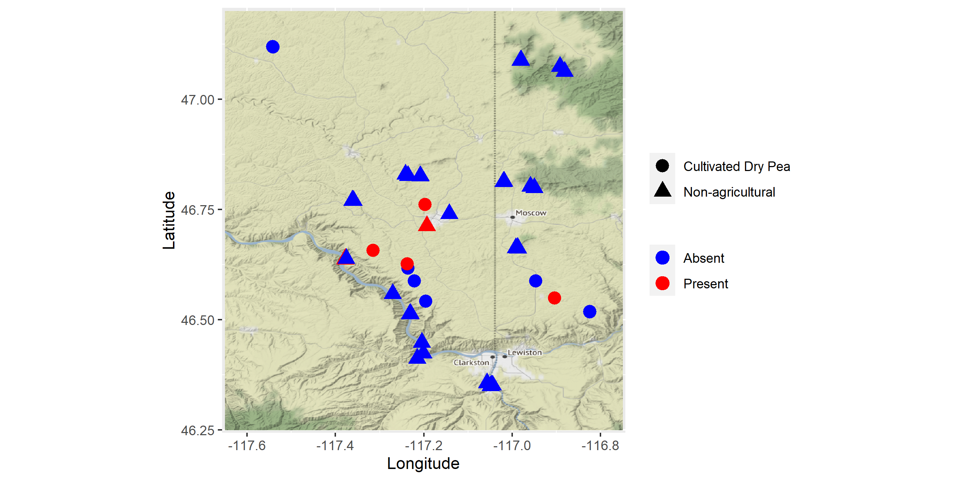

Fig. 2.

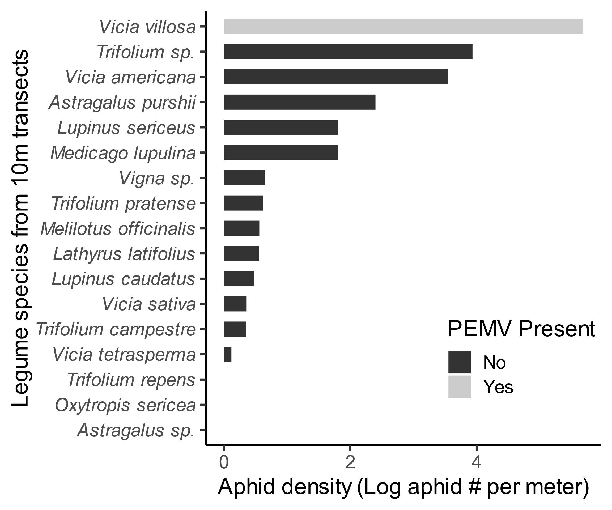

Fig 3. Cumulative plant coverage for non-crop legumes found among all surveys. *Vicia villosa* was the most common non-crop legume.

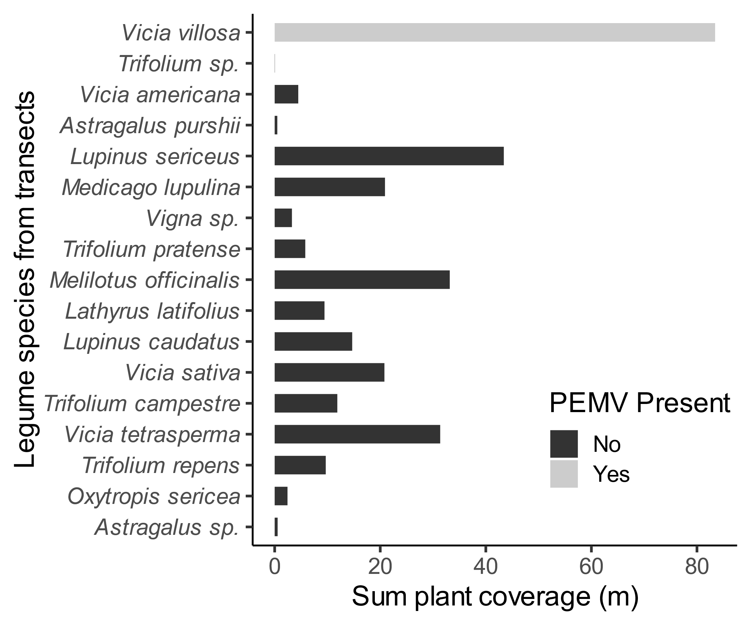

Fig 4. Probability predictions from GLMM (binomial fit) for Pea aphid presence or absence in transects. Aphids were more likely to be present in plant communities containing increasing coverage of Hairy vetch.

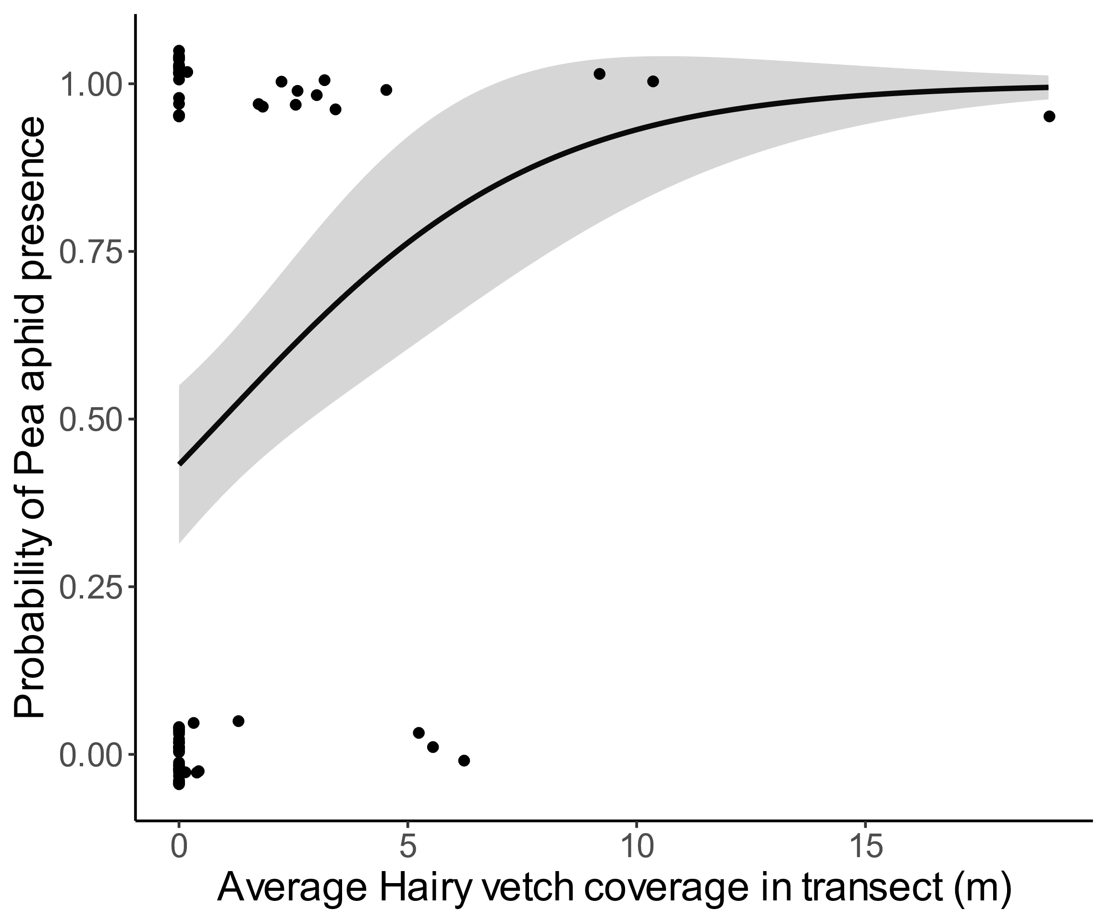

Fig S1. Yearly aphid counts per pan trap over the duration of the “Aphid Tracker” network at University of Idaho (https://www.legumevirusproject.org/). The arrival of alate aphids on pan traps indicates relative pest pressure for the region, which 2014 and 2018 having significantly higher densities than any other years on record (Negative Binomial GLM for year effect on cumulative aphid counts weighted by # of sampling events, *P* < 0.001, χ2 = 59.735).

Fig S2. Example 20m transect from a pea field edge (Ryan Road site).

Fig S3. Large hairy vetch population on cattle-grazed slope west of Clarkston, WA along the Snake River.

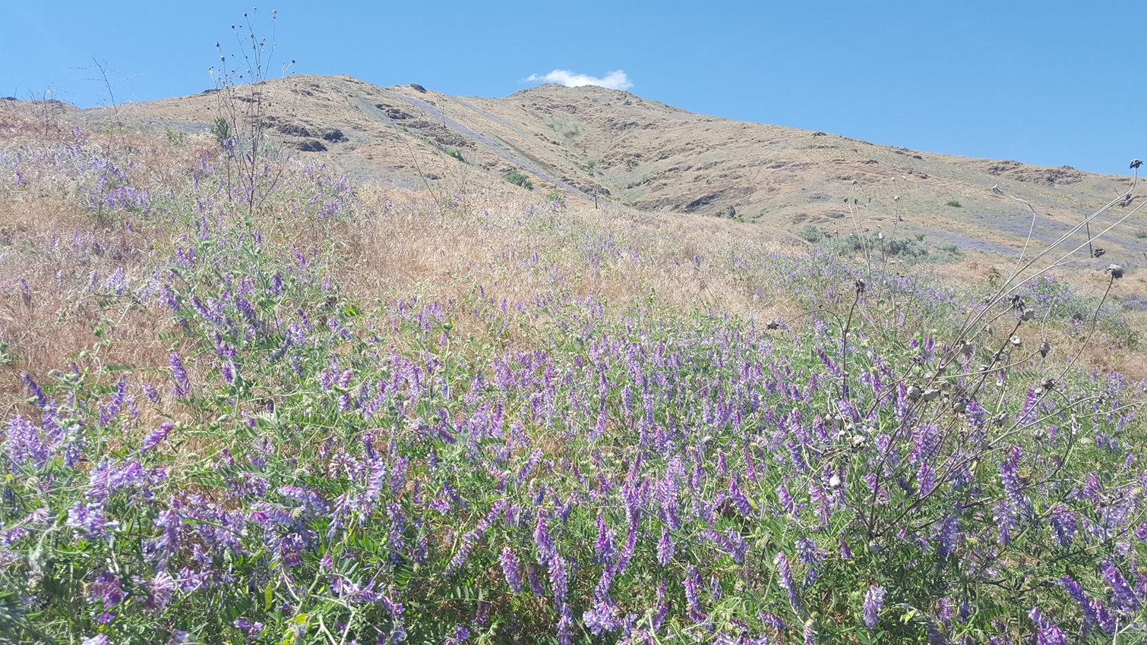

Fig S4. Detection assay for PEMV (electrophoresis gels based on amplification product of PEMV-coat protein). All visible bands were scored as ‘virus presence’ in recipient columns of plants, while no sign of a band was scored as ‘virus absence’. DNA ladder, positive control and negative control shown on far right of each gel image.

